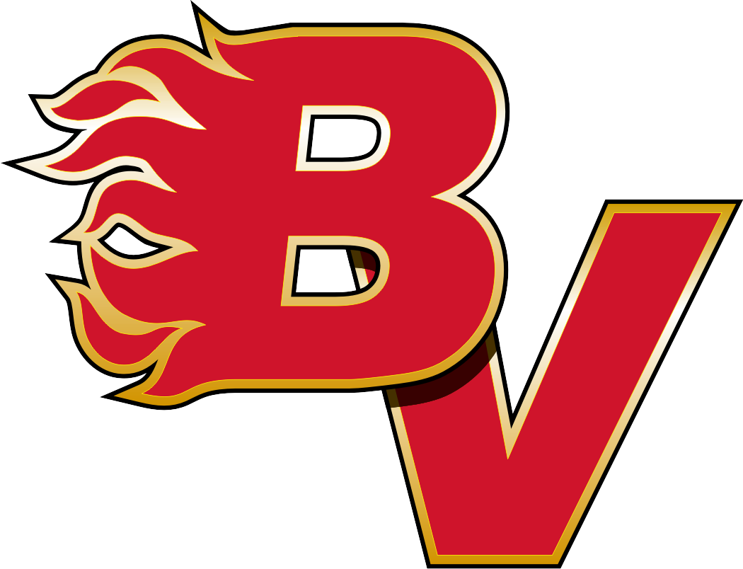
U9 BV FLAMES 2 PINK  1 John Smith (G)  2 John Smith  3 John Smith  4 John Smith  5 John Smith  6 John Smith  8 John Smith  9 John Smith  10 John Smith  11 John Smith  12 John Smith  14 John Smith  15 John Smith  16 John Smith  17 John Smith  18 John Smith  29 John Smith (G)  Coach: Edward Brown  AC: Edward Brown  AC: Edward Brown  AC: Edward Brown  AC: Edward Brown  Manager: Jenny Michaels |  | U9 BV FLAMES 2 PINK  1 John Smith (G)  2 John Smith  3 John Smith  4 John Smith  5 John Smith  6 John Smith  8 John Smith  9 John Smith  10 John Smith  11 John Smith  12 John Smith  14 John Smith  15 John Smith  16 John Smith  17 John Smith  18 John Smith  29 John Smith (G)  Coach: Edward Brown  AC: Edward Brown  AC: Edward Brown  AC: Edward Brown  AC: Edward Brown  Manager: Jenny Michaels |  | U9 BV FLAMES 2 PINK  1 John Smith (G)  2 John Smith  3 John Smith  4 John Smith  5 John Smith  6 John Smith  8 John Smith  9 John Smith  10 John Smith  11 John Smith  12 John Smith  14 John Smith  15 John Smith  16 John Smith  17 John Smith  18 John Smith  29 John Smith (G)  Coach: Edward Brown  AC: Edward Brown  AC: Edward Brown  AC: Edward Brown  AC: Edward Brown  Manager: Jenny Michaels |  | U9 BV FLAMES 2 PINK  1 John Smith (G)  2 John Smith  3 John Smith  4 John Smith  5 John Smith  6 John Smith  8 John Smith  9 John Smith  10 John Smith  11 John Smith  12 John Smith  14 John Smith  15 John Smith  16 John Smith  17 John Smith  18 John Smith  29 John Smith (G)  Coach: Edward Brown  AC: Edward Brown  AC: Edward Brown  AC: Edward Brown  AC: Edward Brown  Manager: Jenny Michaels |  | U9 BV FLAMES 2 PINK  1 John Smith (G)  2 John Smith  3 John Smith  4 John Smith  5 John Smith  6 John Smith  8 John Smith  9 John Smith  10 John Smith  11 John Smith  12 John Smith  14 John Smith  15 John Smith  16 John Smith  17 John Smith  18 John Smith  29 John Smith (G)  Coach: Edward Brown  AC: Edward Brown  AC: Edward Brown  AC: Edward Brown  AC: Edward Brown  Manager: Jenny Michaels
U9 BV FLAMES 2 PINK  1 John Smith (G)  2 John Smith  3 John Smith  4 John Smith  5 John Smith  6 John Smith  8 John Smith  9 John Smith  10 John Smith  11 John Smith  12 John Smith  14 John Smith  15 John Smith  16 John Smith  17 John Smith  18 John Smith  29 John Smith (G)  Coach: Edward Brown  AC: Edward Brown  AC: Edward Brown  AC: Edward Brown  AC: Edward Brown  Manager: Jenny Michaels |  | U9 BV FLAMES 2 PINK  1 John Smith (G)  2 John Smith  3 John Smith  4 John Smith  5 John Smith  6 John Smith  8 John Smith  9 John Smith  10 John Smith  11 John Smith  12 John Smith  14 John Smith  15 John Smith  16 John Smith  17 John Smith  18 John Smith  29 John Smith (G)  Coach: Edward Brown  AC: Edward Brown  AC: Edward Brown  AC: Edward Brown  AC: Edward Brown  Manager: Jenny Michaels |  | U9 BV FLAMES 2 PINK  1 John Smith (G)  2 John Smith  3 John Smith  4 John Smith  5 John Smith  6 John Smith  8 John Smith  9 John Smith  10 John Smith  11 John Smith  12 John Smith  14 John Smith  15 John Smith  16 John Smith  17 John Smith  18 John Smith  29 John Smith (G)  Coach: Edward Brown  AC: Edward Brown  AC: Edward Brown  AC: Edward Brown  AC: Edward Brown  Manager: Jenny Michaels |  | U9 BV FLAMES 2 PINK  1 John Smith (G)  2 John Smith  3 John Smith  4 John Smith  5 John Smith  6 John Smith  8 John Smith  9 John Smith  10 John Smith  11 John Smith  12 John Smith  14 John Smith  15 John Smith  16 John Smith  17 John Smith  18 John Smith  29 John Smith (G)  Coach: Edward Brown  AC: Edward Brown  AC: Edward Brown  AC: Edward Brown  AC: Edward Brown  Manager: Jenny Michaels |  | U9 BV FLAMES 2 PINK  1 John Smith (G)  2 John Smith  3 John Smith  4 John Smith  5 John Smith  6 John Smith  8 John Smith  9 John Smith  10 John Smith  11 John Smith  12 John Smith  14 John Smith  15 John Smith  16 John Smith  17 John Smith  18 John Smith  29 John Smith (G)  Coach: Edward Brown  AC: Edward Brown  AC: Edward Brown  AC: Edward Brown  AC: Edward Brown  Manager: Jenny Michaels

